Access to Medicine Providers in Relation to Demography

Catherine Chen

3-14-2020

**Introduction**

With global outbreak of epidemics like Covid-19, it is essential to understand and evaluate the distribution of medicine services to citizens. Are such facilities distributed in a spatially-evenly way so that most people have equal access to medical services? Or are they spatially concentrated in certain locations of the city?

In particular, as seniors are most likely to be affected by respiratory disease, do they have easy access to medical services? In other words, are medicine providers located close to where seniors are living?

This project examines the distribution of pharmacies in Toronto in relation to the spatial distribution of seniors who are over 65 years old. Relying on the data from Four Square, I retrieve location of pharmacies located within around 140 neighborhoods in Toronto, evaluate the access of each neighborhood, and examine the relationship with senior population.

**Data and methodology**

Four Square provides excellent data for this project. Here are major steps I have used to analyze the spatial distribution of medical service in relation to senior population.

**First**, I collected neighborhood profile data from <https://www.toronto.ca/city-government/data-research-maps/neighbourhoods-communities/neighbourhood-profiles/> and [www.toronto.ca/wellbeing](http://www.toronto.ca/wellbeing).

Main demographic data I download are total population in each neighborhood and population over 65 years old. Based on these data, I calculated the percentage of seniors in each neighborhood.

Spatial coordinates are key in this project. I tried to find coordinates information for each neighborhood in the demographic information that I collected from government web. These attempts turned out to be unfruitful. Then I tried to use geocoding service based on neighborhood names. However, my geocoding packaged did not work either. Therefore, as a final resort, I turned to Google Map and figured out the coordinates of all the neighborhoods in Toronto.

**Second**, I made request to Four Square and get the number of pharmacies within 1000 meters centered around each neighborhood. I originally planned to collected data on clinics and hospitals. However, such calls produced few records from Four Square. Therefore, I had to change plan and concentrate on pharmacies instead. I have a sense that Four Square has a better database for shopping and dining instead of other facilities.

Based on the results, I divided all neighborhoods into two zones, one with easy access to at least one pharmacy store within 1000 meters, and the other without. Population as well senior population in each zone were examined.

**Third**, with all the data I need, I summarized and compared the neighborhoods that have access to pharmacy within 1000km. I developed a logistic model to examine whether the access to pharmaceutical service is related to the distribution of senior population.

All the codes are written in Jupyter Notebook with Python language.

**Analysis**

There are 140 neighborhoods in Toronto. The population in these neighborhoods range from 6,585 to 65,920 in the year of 2016 (Table 1). Population over 65 years old range from 730 to 8,990, and the percentage of senior population has a wide range between 4.8% and 28.0%. Overall, the senior population account for 15.5% of total population in Toronto, lower than the national level of 17.2% in 2018.

**Table 1 Senior Population in Toronto Neighborhoods**

|  |  |  |  |
| --- | --- | --- | --- |
|  | **Senior Pop** | **Pop 2016** | **Pct Senior** |
| **count** | 140 | 140 | 140 |
| **mean** | 3033.11 | 19564.21 | 15.80 |
| **std** | 1593.17 | 10003.19 | 4.27 |
| **min** | 510.00 | 6585.00 | 2.91 |
| **25%** | 1865.00 | 12323.75 | 13.36 |
| **50%** | 2652.50 | 16800.00 | 15.29 |
| **75%** | 3768.75 | 23857.50 | 18.15 |
| **max** | 8990.00 | 65920.00 | 28.02 |

Majority of neighborhoods has a percentage of senior population around 15.3%. The histogram as seen in Figure 1 is roughly bell shaped. There are a few neighborhoods with over a quarter of the population being senior, but the proportion is relatively small.

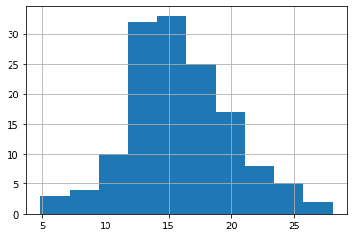

**Figure 1 Percentage of senior population among Toronto neighborhoods**

Based on the data returned from Four Square, 81 or 57.9% of the neighborhoods have access to pharmacy within 1000 meters (Table 2). However, the rest 57.9% do not have immediate access.

**Table 2 Access to Pharmacy Store within 1000 meters from Neighborhood Center**

| **Access to Pharmacy** | **Number of Neighborhoods** | **Percentage of Neighborhoods** |
| --- | --- | --- |
| **0 (No access within 1000 meter)** | 59 | 42.1% |
| **1 (Access within 1000 meters)** | 81 | 57.9% |
| **Total** | 140 | 100% |

Table 3 shows the demographic distribution within the easy access zone and non-easy access zone. The easy access zone covers 3,225 seniors while the non-easy access zone covers 2893. the average senior percentage is 15.6% for the former and 16.05 for the latter.

**Table 3 Access to Pharmacy Store within 1000 meters from Neighborhood Center**

| **Access to Pharmacy** | **Population** | **Senior Population** | **Percent Senior** |
| --- | --- | --- | --- |
| **0 (No access within 1000 meter)** | 19036 | 2893 | 15.62 |
| **1 (Access within 1000 meters)** | 20289 | 3225 | 16.05 |
|  |  |  |  |

Figure 2 shows a map of Toronto neighborhoods divided into Easy pharmacy access (red) and non-easy pharmacy access (purple). Senior residents in downtown Toronto have easier access to pharmacy services compared to other parts of the city.

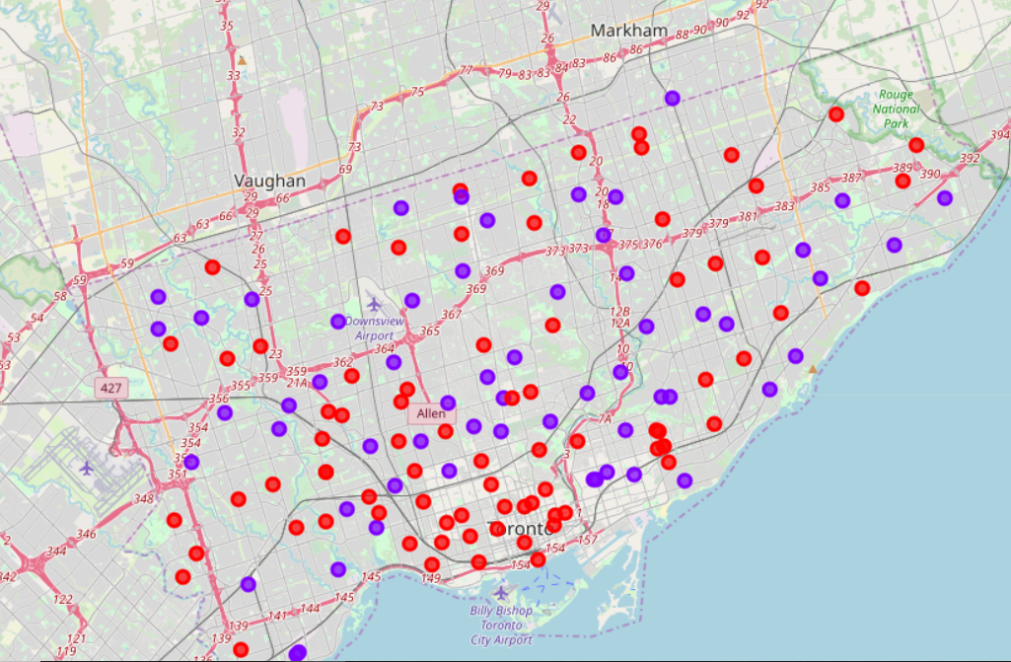

**Figure 2 Toronto neighborhoods (Easy pharmacy access = red, Non-easy pharmacy access = purple)**

Finally, a logistic regression was developed to examine the relationship between access to pharmacy stores and senior population. The dependent variable is whether a neighborhood has easy access to at least one pharmacy store within 1000 meters. The value is dichotomous. The independent variables include the total population, senior population, and the percentage of senior population.

Results in Figure 3 show that the model has weak power with a R squared of 0.01, and none of the independent variable has any significant impact upon the dependent variable. These results suggest that there is little association between the spatial distribution of pharmacy store and senior population.

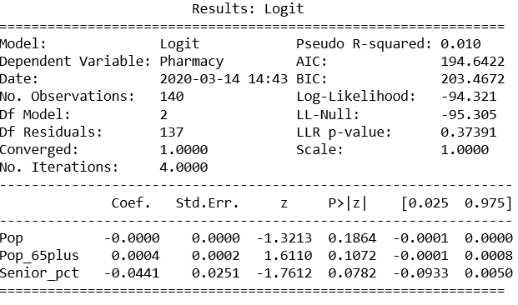

**Figure 3 Logit model on the access to pharmacy service**

**Conclusion**

Depending on Four Square API, I found that 57.9% of the neighborhoods have access to at least one pharmacy service within 1000 meters of the neighborhood center. The easy access zone covers 3,225 seniors while the non-easy access zone covers 2893. the average senior percentage is 15.6% for the former and 16.05 for the latter.

Senior residents in downtown Toronto have easier access to pharmacy services compared to other parts of the city.

Results in Figure 3 show that the model has weak power with a R squared of 0.01, and none of the independent variable has any significant impact upon the dependent variable. These results suggest that there is little association between the spatial distribution of pharmacy store and senior population.

These results suggest that there is still space for the Toronto city government to provide more pharmacy service to its residents, and to give special consideration to its senior citizens.